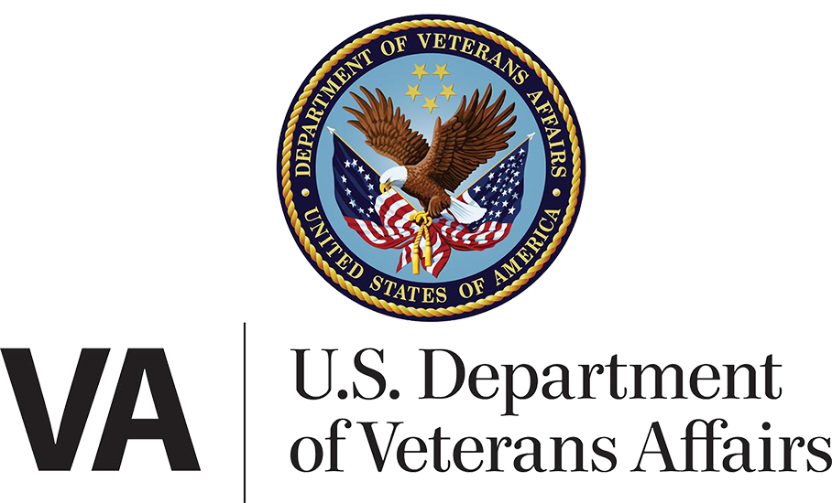

**Dependent Management Tools:  
Dependency Verification**

**Version: 1.0  
Launch: September 2, 2025**

**Revision History**

| Date | Version | Description | Author |
| --- | --- | --- | --- |
| 8/21/2025 | 1.0 | Production MVP | Jacob Worrell |

**Table of Contents**

1. Dependency Verification Overview 4

2. User Access 4

3. Navigation 4

4. Functionality 7

5. Major Issues and Error Messages 18

6. Email Notifications 19

## 1. Dependency Verification Overview

Dependency verification is a process that allows VA to confirm whether the dependents listed on a Veteran’s record are still accurate. Keeping this information up to date ensures that Veterans receive the correct monthly compensation and helps prevent overpayments or future debt. On paper, this process is handled through **VA Form 21-0538, Status of Dependents Questionnaire**. The new Dependency Verification MVP on VA.gov is a first step toward bringing this process online. For now, the tool only supports Veterans who want to verify that **there are no changes** to their dependents. Veterans who need to add or remove dependents will still need to complete VA Form 21-686c or VA Form 21-674.

## 2. User Access

Users must be logged in to VA.gov to have access to the product.

## 3. Navigation

**Direct URL:** <https://va.gov/manage-dependents/verify-dependents-form-21-0538/introduction>

Users can navigate to the above URL through two primary pathways.

Path A (when the user is not logged in):

1. From the homepage, click the [Review or update your dependents](https://staging.va.gov/view-change-dependents) link.

1. On this page, users will be asked to log in. They will need to do so to continue

1. Click “[View current dependents](https://staging.va.gov/view-change-dependents/view)”

1. Click the “[Verify your VA disability benefits dependents](https://staging.va.gov/view-change-dependents/verify-dependents-form-21-0538)” link

Path B (when a user is already logged-in):

1. Click their own name in the top right corner and then click “Dependents” from the drop-down menu.

1. Proceed with steps 3 and 4 described in Path A

## 4. Functionality

From the dependency verification page, veterans should be sure to review the descriptions of the steps.

If the Veteran would like to begin the verification process, they can click the link **Start your disability benefits dependents verification**

Clicking the link begins the form experience. Veterans will first be asked to review some personal details. Unfortunately, sensitive information like social security numbers cannot be changed on VA.gov at this time. If the Veteran would like to make changes to the information on this page, they will have to call VA.

Once the Veteran clicks continue, they will go to Step 2 of the form. Here they will confirm contact information. If any information is incorrect, they can click “edit” and change the information  
  
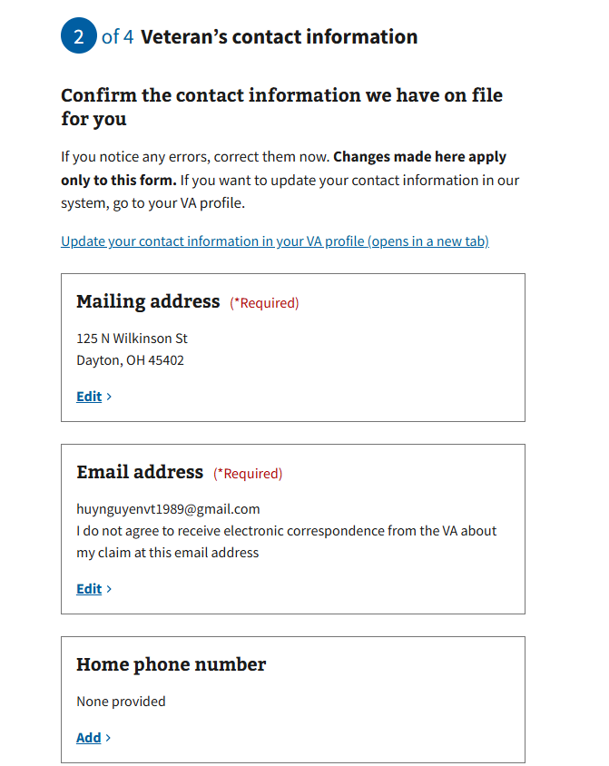

Clicking “edit” or “add” will navigate them to a new page in which they can make the necessary updates.

When the Veteran is finished updating their contact information, they can click “Continue” and proceed to Step 3 of the form. The first thing the Veteran should do is review the dependents currently on file.

Once they review the dependents on file, the Veteran can scroll down the page and decide whether they want to verify the information is still correct or update their dependents records.

If the Veteran decides they do want to update dependents’ information, they can select the “Yes” option and they will be redirected to the Add/Remove (686c/674) form flow.   
  
If the Veteran wants to proceed with verifying their dependents are up to date, they can select “No”. Doing so will take them to the last step in the form. Here they should review all the information they’re about to submit to VA by clicking on the accordion items.

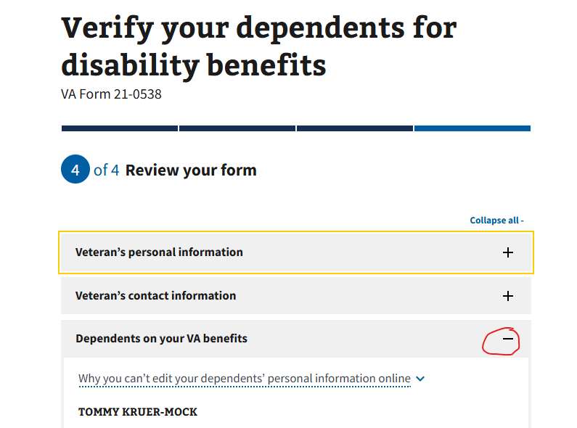

Veterans will also again have the opportunity to edit their personal information from this page

Once all the information is verified and updated appropriately, the Veteran will have to sign their name exactly as instructed, click the “certify” checkbox, and then click “submit form”. This will send the submission to VA.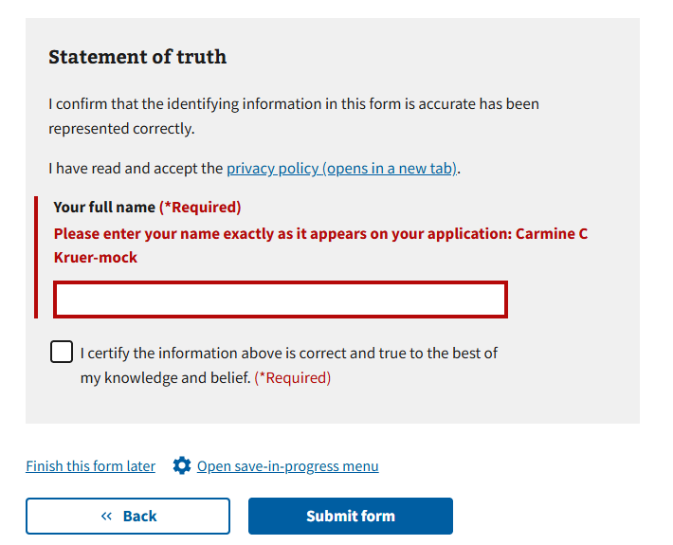

Finally, the Veteran will be directed to a confirmation page with information about how to view their submission. They should save their confirmation number.  
  
## 5. Major Issues and Error Messages

Error messages are in place for VA maintenance and other service disruptions. In both cases, the user is notified and asked to check back later.

## 6. Email Notifications

If a user’s submission from VA.gov fails to reach the appropriate processing teams due to a downstream system error, the Veteran will be notified via email that the submission has failed, and they’ll need to resubmit.